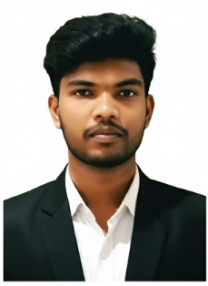

NOYAL SURYA J J
Dubai, UAE [Visit Visa]
suryanoyal@gmail.com | +971 505 655 798
linkedin.com/in/surya-noyal | Portfolio: noyalsurya.in

PROFESSIONAL SUMMARY
Creative Content creator and videographer with more than four years of experience making short-form content for influencers and brands in the lifestyle, entertainment, and personal branding fields. Used data-driven storytelling, creative direction, filming, and editing to get 22 million and more organic views. Skilled in building performance-focused content that increases reach, engagement, and audience retention across Instagram and digital platforms.

CORE COMPETENCIES
Growth & Social Media
Social Media Strategy, Instagram Growth, Reels Strategy, Viral Content Creation, Content Planning, Influencer Marketing, Brand Positioning, Community Management, Campaign Management, Audience Research, Trend Analysis, Performance Analytics, KPI Tracking, Engagement Optimization, Conversion Strategy, Content Audits, Growth Experiments, Meta Business Suite, Instagram Insights, YouTube Studio, Google Analytics, Content Funnels, A/B Testing, Performance Analytics, KPI Dashboards
Innovative & Branding
Figma, Adobe Photoshop, Adobe Illustrator, CapCut, Adobe Premiere Pro, Adobe After Effects, Canva, Visual Branding, UGC Strategy, Visual Storytelling, Creative Direction, Motion Graphics, Brand Identity, Content Design, Storytelling, Graphic Design, Motion Graphics, Video Editing, Script Writing, and Brand Voice
Marketing & Business
Brand Strategy, Performance Marketing, CRM Basics, Content Strategy, Campaign Planning, Audience Segmentation, Conversion Optimization, Client Management, Account Management, Digital Marketing, Product Marketing, Market Research, Strategic Planning, Presentation & Pitching, Team Leadership, Project Coordination, Stakeholder Communication

PROFESSIONAL EXPERIENCE
Social Media Growth Manager & Creative Strategist (Freelance) 2022 - Present
Created high-performing digital content and scalable growth systems by collaborating with influencers, agencies, and brands in the entertainment, lifestyle, education, and personal branding sectors.
Achievements:
- Viral short-form content generated over 22 million organic views.
- Created 100+ performance-focused videos between 2022–2025.
- Developed content systems that increase engagement by 300% to 800% within 6 months.
- Created visual identities and content formats unique to the brand.
- Less reliance on sponsored advertisements thanks to effective organic reach tactics.

Responsibilities:
- Scripting, creative direction, and content ideation
- Production of reels and short-form narrative
- Social media visual branding
- Growth reporting and performance analysis
- Strategy for community engagement
- Planning for influencer collaboration
- Audits and monthly content calendars
Creative Content Designer – Music Temple Pvt Ltd, IITMRP October 2024 – November 2025
- Developed and produced successful short-form content for entertainment and music companies.
- Managed the entire content pipeline, which included motion graphics, editing, shooting, scripting, and concept development.
- Worked together with internal teams and artists to create visually coherent brand content.
- Improved audience retention and engagement through hook-based storytelling and trend-driven formats.
- Contributed to numerous viral posts as well as steady increases in interactions and reach.

Content Creator – Roarr Media Pvt Ltd December 2025 – Present
- Create content for many client brands on social media that is focused on performance.
- Lead the creative side of short-form campaigns, from coming up with ideas to writing scripts, filming, and editing.
- Use platform analytics, audience insights, and content strategy to get the most people to see and interact with your content.
- Work closely with marketing teams to align creative output with brand objectives and campaign goals.
- Produce scalable content formats that drive consistent visibility and audience growth.

LEADERSHIP EXPERIENCE
Chief of Operations – TEDx Panimalar Engineering College 2024
- Led the entire processes for a large-scale public event.
- Managed design, content, marketing, and administration teams.
- Coordinated marketing, promotions, and partnerships.
- Ensured seamless execution and positive audience experience.
- Handled budgets, vendors, and event logistics.
Editorial Head – PEC Hacks (International Hackathon) 2024 - 2025
- Managed communications and content for a hackathon at the international level.
- Created brand messaging and digital marketing campaigns.
- Directed the storytelling approach and social media presence.
- Led the creative and editorial teams.
- Collaborated with sponsors and partners to align content with event goals.

KEY ACHIEVEMENTS
- More than 22 million organic views of viral short-form content
- Handling more than six expert brand accounts
- Built high-performing content systems without paid ads
- Directed international event branding and promotion
- Produced performance-driven creative work on a regular basis

EDUCATION
B.Tech – Computer Science & Business Systems 2021 - 2025
- Concentrated on data-driven decision making, digital systems, and business strategy.
- Extensive experience with communication, brand management, and marketing analytics.
- Applied systems thinking to practical business and digital issues.

PERSONAL INFORMATION
Name : Noyal Surya J J
Father’s Name : Joseph Dungston P
Marital Status : Single
Date of Birth : 24-12-2003
Languages : English (Fluent), Tamil (Native), Malayalam (Conversational)

DECLARATION
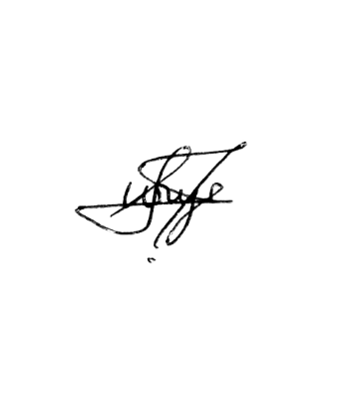
I, Noyal Surya J J, hereby declare that all the facts and information stated above are true and complete to the best of my belief and knowledge, and I hold responsibility for the correctness of the above-mentioned particulars.

Place: India
Signature
(Noyal Surya J J)

